Enhancing medication adherence through an IoT-enabled automated pill dispenser with real-time monitoring
^{Name of Authors}
Department of Artifical Intelligence and Cyber Security, Ramdeobaba University, Nagpur, India.

Email:

Abstract
Medication nonadherence influences Good Health and Well-being's SDG 3. This paper presents an IoT-enabled automated pill dispenser with remote monitoring, accurate scheduling, and automatic dispensing promoting medication adherence. Running an Arduino Uno microprocessor, ESP8266 Wi-Fi module, servo motor, circular medication tray with four divisions to control pill distribution. Real time alerts from the Blynk app notify patients and caregivers. Stressing hardware instead of visual or aural alarms guarantees simplicity and dependability. An RTC module keeping appropriate dose schedules aids to sustain remote adherence tracking made possible by Wi-Fi connection. Many repeats revealed a constant drop in failure rates, therefore demonstrating the robustness and effectiveness of the system. In many healthcare environments, affordable design and a simple interface fit. Future directions will be integration of advanced analytics for adherence optimization and system customizing for medical needs.
Keywords: IoT, Automation, Medication, Pill Dispenser, Monitoring.
1. Introduction
Prescriptions should be followed by strict dose dependent chronic patients [1]. Ignoring drug instructions could cause serious medical issues, less effective treatment, and more costly healthcare [2]. Older or multi-medication patients are more prone to blunders since traditional treatments such as alarm reminders and pill organizers depend on human consistency and memory [3]. The Internet of Things (IoT) devices and objects compile, interact, and act on data to so improve automation and efficiency in all areas [4]. Medication delivery is simplified [5], [6] via remote notifications, real-time monitoring, and automatic dispensing—which IoT-based pill dispensers simplify. Managing dispensing algorithms to release medications on demand is done using a real-time clock. The Blynk app real-time alerts patients and caregivers of missing doses and prescription adherence. IoT has brought solutions for drug adherence, better patient care, and tools for creative health management systems. IoT neatly links tools, patients, and caregivers to improve healthcare systems. New IoT-based pill dispensers increase medication intake and schedule adherence accuracy. These devices reduce human mistake and improve living for elderly and chronically sick people by different drug dosage [7]. IoT-driven pharmaceutical solutions on cloud platforms allow family members and doctors to monitor adherence and respond to missing doses remotely. These advances improve doctor-patient relationships and results. Smart healthcare systems holistically serve patients with real-time health monitoring and drug delivery. Automated tablet distribution and vital sign monitoring assist Alzheimer's and autoimmune disease patients. Remote health data access for family and doctors as well as automatic medication reminders aid to guide decisions and prevent mistakes. Reducing explicit and audible messages helps to give scalability, usability, and efficiency first priority. An inexpensive, basic, programmable dispenser can help some patients to increase prescription adherence, error rates, and healthcare outcomes.

This paper is organized as follows: Section 2 provides a critical review of existing IoT-based medication management systems and automated dispensing architectures. Section 3 details the proposed methodology, encompassing system logic, hardware specifications, and overall architectural design. Section 4 specifies the implementation environment, including software tools, hardware integration protocols, and configuration parameters. Section 5 evaluates the prototype’s performance through rigorous testing for accuracy, reliability, and stress-testing under varied user inputs. Finally, Section 6 synthesizes the findings, discusses technical constraints, and outlines prospective research directions.
2. Literature review
The IoT enabled drug management improves treatment quality, accuracy, and adherence. IoT gadgets include CMOS cameras and image-processing systems. Emails reminding missing doses help to reduce computational and sensor costs [8]. IoT pill dispensers and smart cups integrating accelerometers and gyroscopes for consumption validation are examples of advanced technologies. Bluetooth Low Energy devices support drug scheduling and adherence [9]. Distribution of infrared contactless sensors for COVID-19 detects drug use and temperature. IoT devices must warn caregivers and stop physical interaction to guarantee prescription compliance in extreme conditions [10]. IoT-driven medication dispensers assist with memory of dosages for elderly and dependent people. In these devices, alarms and real-time caregiver communication raise patient safety [11]. Using facial recognition, advanced smart dispensers safely dose. These consistent and moderately priced geriatric devices have load cells for drug levels and sections for drugs unique to time-series [12]. Real-time drug control allows Alzheimer's patients to choose their prescriptions [13]. In multi-patient systems including notifications, LED indicators, and mobile device alerts, safe access, remote management, and dose accuracy come first [14]. By means of real-time monitoring, dose scheduling, and authentication, IoT smart devices fight prescription abuse and drug addiction. These regulations improve the harmony between pharmaceutical safety and medical practice [15]. SIMMS make use of LED, buzzers, wireless connectivity, and other inventive monitoring devices. Early Blynk apps improve caregiver communication and patient adherence [16].
3. Methodology
The system architecture illustrated in Fig.1 a centralized control approach where the ESP32 microcontroller integrates timing, communication, and dispensing functions. The RTC ensures accurate scheduling of medication, while the GSM module enables remote alerts and monitoring. Supporting modules such as LCD display, voice memory, and switch enhance user interaction and accessibility. The coordinated operation of these components ensures reliable medicine dispensing through the automated medicine box.
Fig. 2 (a) shows IoT-enabled pill dispenser logic. RTC, servo motor, Wi-Fi starts system controls. Track main loops time versus intervals. Servos set Blynk alerts on games, distribute pills from the correct container, and light LEDs. Method demands four straight runs over containers. Fig. 2 (b) show ESP8266 module warning and Blynk application. Blynk servers' WiFi is ESP8266-based. The Blynk dashboard displays event status together with scheduled reminders for caregiver and patient "Time to take medicine". This generates instantaneous changes on drug adherence.

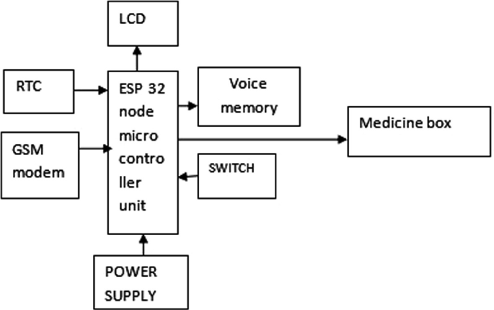
Fig. 1. System architecture of the IoT-enabled automated medicine dispensing system
The Arduino control system lays out the medication schedule and starts hardware. SET calls RTC, servo motor, Wi-Fi module initialization. This cycle never breaks, matching the present instant with the prescription calendar. The circular tray releases tablets at the prescribed moment by use of a servo motor.

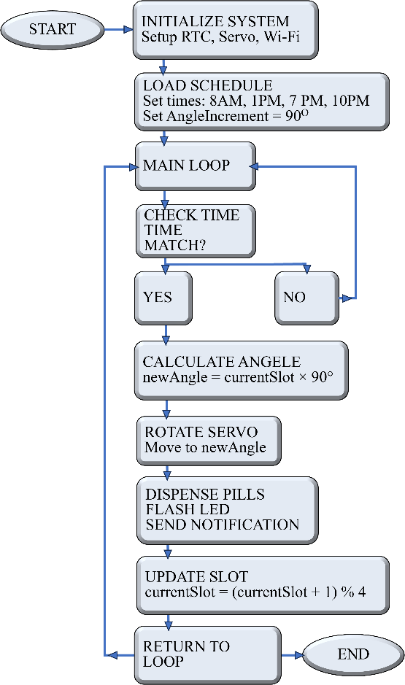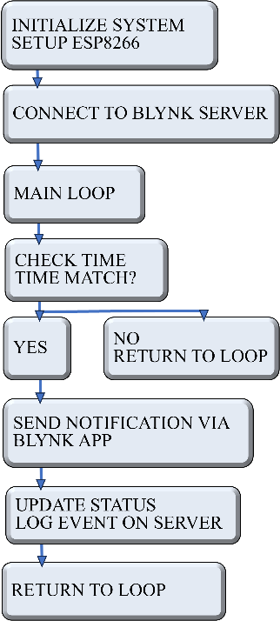
- (b)
Fig 2. Flowchart showing the operational logic of (a) the IoT-based pill dispenser and (b) dedicated notification process using Blynk app with ESP8266 module.
The Blynk app notifies you. The Blynk program finds a flaw in a dispensing or dosage-related system. Aimed at low power usage and perfect running, the method ensures dependability and efficiency.
4. Prototype Design and Hardware Integration
Designed and implemented to guarantee flawless drug administration was the IoT-enabled automatic pill dispenser. The device combines Arduino Uno microcontroller, ESP8266 Wi-Fi module, four-compartment circular medication tray, servo motor, small plastic sliding track guiding pills onto a tray. Precise control over pill distribution and real-time monitoring via the Blynk app depends on careful hardware setting guaranteeing efficient functioning. The Arduino Uno consists mostly in running the preset schedule and regulating servo motor motions. It also consists in the main controller. The ESP8266 Wi-Fi module ties the Blynk server and allows alerts for patients and caregivers. The servo motor runs the pharmaceutical tray to line the suitable compartment with the dispensing chute; a real-time clock (RTC) module guarantees correct timing for dispensing. In handling prescription scheduling, the design emphasizes dependability, simplicity, and little handling area.
Stressing the internal connections of all components, Fig. 3 (a) illustrates the full hardware arrangement including the Arduino Uno, ESP8266 module, servo motor, and power supply, coupled to a laptop for programming and monitoring. Fig. 3 (b) offers a close-up view of the four-compartment circular dispenser, therefore guaranteeing accurate and user-friendly medicine delivered with a limited sliding track directing pill into the tray.
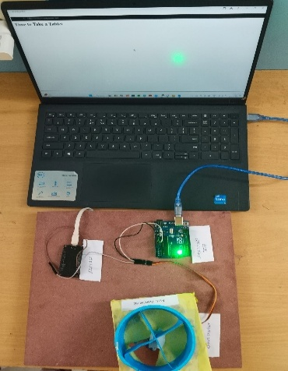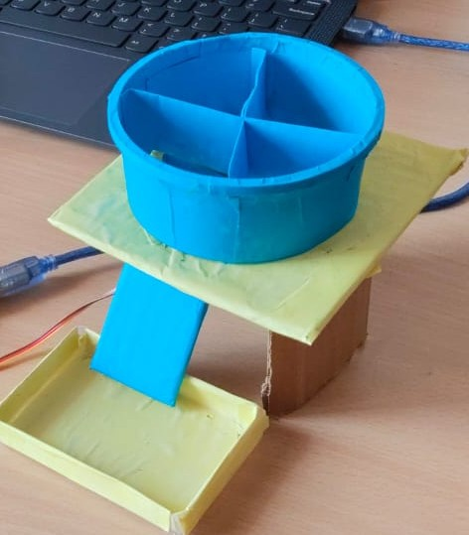
- (b)
Fig 3. (a) Complete hardware setup with all components connected and interfaced with a laptop. (b) Pill dispenser with sliding track and tray for pill delivery.
5. Results and discussion
Fig. 4 enumerates the main justifications for the medical domain's pill dispenser implementation. Twenty volunteers in all—relatives, family members, Neighbors, and friends—were requested to complete a survey in order to gather information. The poll was meant to emphasize the common social concerns about drug distribution. Emphasizing the part automation addresses specifically issues including forgetfulness, dependency, and convenience; it helps to boost the effectiveness of healthcare.
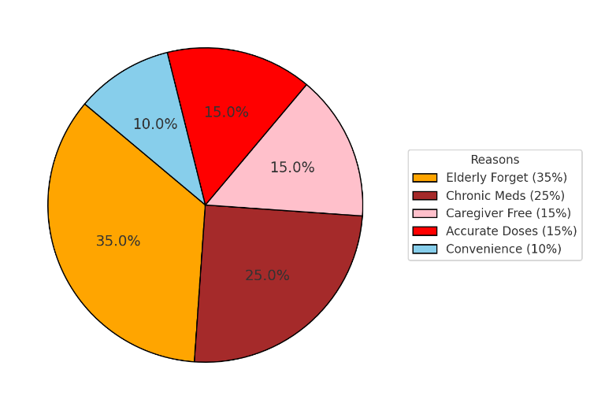
Fig 4. Reasons for adopting pill dispensers in healthcare.
The servo motor's rotation angle shown in Fig. 5 (a) lines with the following dispensing times: ten in the evening before bed, seven in the evening after dinner, eight in the morning after breakfast, one in the afternoon following lunch.
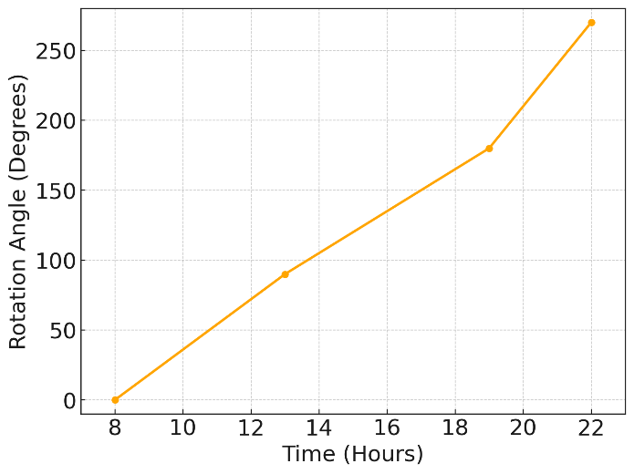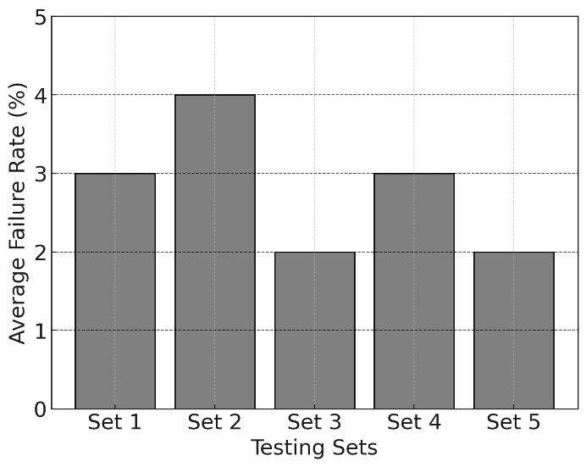
(b)
(a)
Fig 5. Servo motor rotation angle mapped to scheduled dispensing times (b) Average failure rates across testing sets.
The servo motor runs through a whole 90 degrees at each of the specified intervals to line itself with one of the four compartments, therefore guaranteeing accurate and timely drug administration. The plot helps to stress the system's dependability and accuracy in executing the set plans.
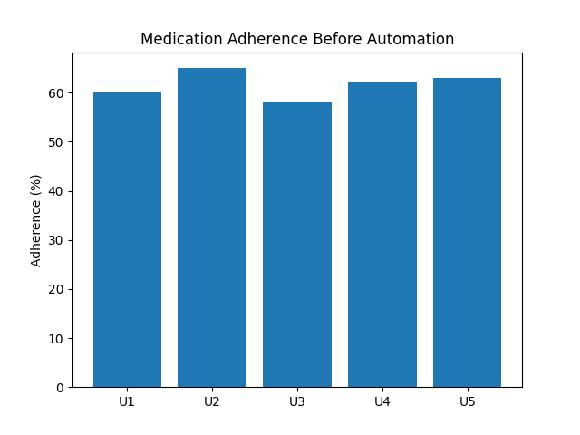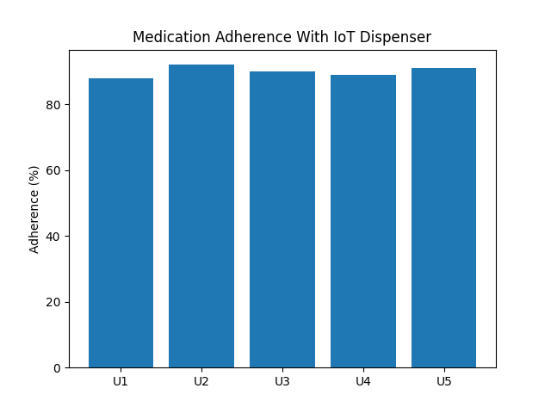
(b)
(a)
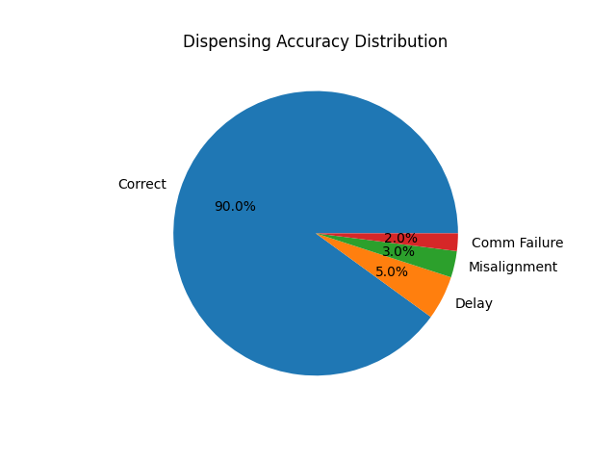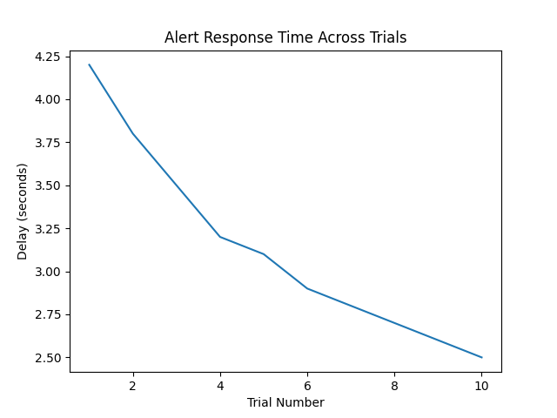
(d)
(c)
Fig. 6. Performance evaluation of the proposed IoT-enabled automated pill dispenser:(a) Medication adherence under manual reminder conditions, (b) Medication adherence with IoT-assisted dispensing, (c) Alert response time across multiple operational trials, and (d) Distribution of dispensing accuracy indicating system reliability.
Fig. 5 (b) displays, for any one of the five testing sets, the average failure rates noted over ten iterations. It does this by showing two to four percent of a consistent decline in failure rates over iterations. This ensures the system's lifespan. Mostly misalignment of the servos, communication issues, and scheduling irregularities caused failures; all of these were gradually overcome.
The multi-panel analysis shown in Fig. 6 (a)–(d) demonstrates the effectiveness and reliability of the proposed IoT-enabled pill dispenser system. A clear improvement in medication adherence is observed in Fig. 6 (a) and Fig. 6 (b) when comparing manual reminders with automated IoT-assisted dispensing. The alert response time plot in Fig. 6 (c) confirms consistent real-time notification performance across trials. Additionally, the dispensing accuracy distribution in Fig. 6 (d) indicates high system precision with minimal operational failures, validating the robustness of the proposed design for practical healthcare deployment.
6. Conclusion
This work presents the design and execution of an IoT-enabled automated pill dispenser targeted to improve prescription adherence, accuracy, and convenience. Combining an Arduino Uno CPU, an ESP8266 Wi-Fi module, and a servo motor guarantees accurate and timely medicine distributed. Notifications sent by the Blynk program give patients and caregivers real-time data, therefore guaranteeing suitable drug compliance. Several testing run proved the dependability of the system; modest changes and upgrades surely help to lower failure rates. Older patients and those with chronic diseases needing rigorous medication regimes would find the device particularly appropriate for its small and straightforward design. This dispenser reduces errors and hence handles important issues by including IoT capabilities to handle critical drug management issues including forgetfulness and reliance. The technology's affordability and scalability fit more general utilization in medical environments. Since it lets to reduce healthcare costs and enhance quality of life, the automated pill dispenser looks to be a general useful tool in general in enhancing patient care and medication compliance.
7. References
[1] Sheetal A. Singh, S. S. Balpande, “Development of IoT-Based Condition Monitoring System for Bridges”. Sound & Vibration, Vol.56, No.3, 2022, pp.209-220, https://doi.org/ 10.32604/sv.2022.014518.
[2] Mayuri D. Dhone, Poonam G. Gawatre, Suresh S. Balpande, Frequency band widening technique for cantilever-based vibration energy harvesters through dynamics of fluid motion, Elsevier & KeAi, Materials Science for Energy Technologies, Volume 1, Issue 1,2018,Pages 84-90, ISSN 2589-2991, https://doi.org/10.1016/j.mset.2018.06.002.
[3] Suganya, Ganesan, M. Premalatha, S. Anushka, P. Muktak, and J. Abhishek. "IoT based automated medicine dispenser for online health community using cloud." Int. J. Recent Technol. Eng 7, no. 5 (2019): 1-4.
[4] A. Tripathi et al., "Implementation of an Alert System Integrated into Smart Wireless Helmets Utilizing IoT Sensors," in ICNWC, IEEE, 2024.
[5] Ramkumar, J., C. Karthikeyan, E. Vamsidhar, and Kale Navnath Dattatraya. "Automated pill dispenser application based on IoT for patient medication." In IoT and ICT for Healthcare Applications, pp. 231-253. Springer, 2020
[6] Ali, Hassan, Hafsa Khan, Abdul Haseeb, Haris A. Yazdani, and Gul Munir. "Smart pill dispensing and vital sign monitoring system." In AIP Conference Proceedings, vol. 3125, no. 1. AIP Publishing, 2024.
[7] Sahu, Deepak K., Bikash K. Pradhan, Slawomir Wilczynski, Arfat Anis, and Kunal Pal. "Development of an internet of things (IoT)-based pill monitoring device for geriatric patients." In Advanced methods in biomedical signal processing and analysis, pp. 129-158. Academic Press, 2023.
[8] Peddisetti, Vinay, Pavan Kumar Kandregula, Joel Anil John, Suseela Poomdla, Kiran George, and Anand Panangadan. "Smart Medication Management: Enhancing Medication Adherence with an IoT-Based Pill Dispenser and Smart Cup." In 2024 IEEE First International Conference on Artificial Intelligence for Medicine, Health and Care (AIMHC), pp. 137-144. IEEE, 2024.
[9] Nayak, Manjushree, Jiten Kumar Gardia, Umashankar Ghugar, Amit Jain, and Rakesh Nayak. "Revolutionizing Healthcare Management: IoT-Based Medicine Dispenser and Temperature Monitoring Systems." In 2024 OPJU International Technology Conference (OTCON) on Smart Computing for Innovation and Advancement in Industry 4.0, pp. 1-6. IEEE, 2024.
[10] M Patil, C. H., Nakia Lightwala, Mehul Sherdiwala, Amol D. Vibhute, Sachin A. Naik, and Shankar M. Mali. "An IoT based smart medicine dispenser model for healthcare." In 2022 IEEE World Conference on Applied Intelligence and Computing (AIC), pp. 391-395. IEEE, 2022.
[11] Sudarmani, R., J. Harshitha, and K. Rajakumari. "Development of Smart Automatic Drug Dispenser for Elderly and Disabled People." In 2024 International Conference on Science Technology Engineering and Management (ICSTEM), pp. 1-5. IEEE, 2024.
[12] MohanaPriya, D., V. Deepika, M. Shanmugha Priya, and C. Sivasankari Yogeswari. "A real time support system to impart medicine using smart dispenser." In 2020 International Conference on System, Computation, Automation and Networking (ICSCAN), pp. 1-10. IEEE, 2020.
[13] Nguyen, Ky-Suong The, Van Lanh Nguyen, and Minh-Tien Nguyen. "IoT System Design for a Smart Medicine Dispenser Serving Multiple Patients." In The International Conference on Sustainable Energy Technologies, pp. 249-257. Singapore: Springer Nature Singapore, 2023.
[14] Ankireddypalli, Rekhitha Sree, and Kandi Sriya Sushrutha Reddy. "IoT Based Smart Drug Administrator and Dispenser." In 2023 International Conference on New Frontiers in Communication, Automation, Management and Security (ICCAMS), vol. 1, pp. 1-6. IEEE, 2023.
[15] Abdullah, Azian Azamimi, Kwan Janson, and Wei Chern Ang. "Development of Smart Intelligent Medicine Monitoring System (SIMMS)." In Symposium on Intelligent Manufacturing and Mechatronics, pp. 761-770. Singapore: Springer Nature Singapore, 2023.
.[16] A. Abdullah et al., "Smart Intelligent Medicine Monitoring System," Springer, 2023.
[17] Gargioni, Luigi, Daniela Fogli, and Pietro Baroni. "A Systematic Review on Pill and Medication Dispensers from a Human-Centered Perspective." Journal of Healthcare Informatics Research 8, no. 2 (2024): 244-285.
[18] Kumar, S. Kalimuthu, R. Manimegalai, A. Rajeswari, R. Deekshita, M. Dhineshkumar, and G. Manikandan. "A literature review: performance evaluation of wearable system with pill dispenser box for post

.

